communication Networks

Communication Networks

TEST CERTIFICATE

Document control:
Certificate Name | Functional Acceptance Testing for:  DLMS 11MP5_CC1_V1_FPH7G01
Certificate Number: | Program 11MP5_CC1_V1
Version No. | 1.0
Created on | Monday, 18 March 2024
Last Updated | Thursday, 12 March 2026
Status: | FINAL

Approval Status
Test Certificate Approved |  |  | Date
Stake Holder Title | Stakeholder Name | Approval Signature |  | Date
AMI Metering and Communications Engineer | Andy Hurst |  |  | 28/03/2024

Business in Confidence
Document Details

Roles | Name
Document Owner | Minh Le
Document Administrator | Leonard Jarillas

Document purpose
The purpose of this Communication Networks Test Certificate is to document the outcomes and recommendations found whilst testing DLMS 11MP5_CC1_V1_FPH7G01
change control
- The Document Owner will approve changes to this test certificate document
- The Document Administrator will be responsible for communicating changes to the wider business

Document Review

Reviewer Title | Reviewer Name | Reviewer Signature | Date
Manager Communication Networks Quality | Leonard Jarillas | <>

CONTENTS
1 SUMMARY 1
2 INTRODUCTION 1
2.1 Background 1
2.2 Motivation for testing 1
3 TEST DETAILS 1
3.1 Testing methodology 1
3.2 Details of combination tested 2
3.3 Test Results Overview 3
3.4 Test Results Summary 3
4 Recommendation 4
5 Issues Found DURING TEST 4
6 Deployment notes 4
6.1 Deployment Notes 4
7 approval 5
8 REvision History 5

SUMMARY
Meter programs are responsible for defining the settings within a meter. These settings affect the function of the meter and how it records metering data. A meter program for SECURE DLMS 11MP5 meters has been developed to allow the recording of 5-minute interval data for Active import and export energy. This program is named “11MP5_CC1_V1”.
Prior to the remote deployment of program 11MP5_CC1_V1, for 11MP5 meters into the production AMI system it is deemed important to ensure that this meter program poses no risk to the business. To achieve this, the Communication Networks Quality group carried out testing to ensure correct functionality (see section 3.4 for details).
Testing for the remote deployment of SECURE DLMS meter program 11MP5_CC1_V1 for 11MP5 meters is complete. It was carried out with the configuration detailed in section 3 “Details of the Combination Tested”.
It is recommended that meter program 11MP5_CC1_V1 for 11MP5 meters can be remotely deployed within the AMI Network with minimal risk to the business.

INTRODUCTION

Background
As the DPI compliant PACT meters are approaching end of life and ITRON has planned obsolescence for NIC 3, a new generation meter (SECURE DLMS) with improved processor, memory and Itron NIC 5 is needed to cater the VIC market. The released CLEM is DPI compliant and includes new feature set critical to business.

Prior to roll out of the new meters, it is necessary to test the meter programs to ensure that it can be deployed to the production environment with minimal risk to the business.
Specifically, the following settings can be changed in a meter program:
- Interval data channels
- Energy Registers
- Quality of supply / Supply capacity thresholds
- LCD display settings
- Load control switching time
- Event log recording.

Motivation for testing
Version 1 of 11MP5_CC1 has been created to enable the introduction of Secure DLMS meters into the VPN AMI meter fleet as described in the document ‘VPN Meter Contract Customer Input for Secure DLMS meters’. The introduction of which contributes to the aligning of the UE and Powercor networks.
Particular testing activities are required in the areas of:
• New DLMS functionality
• New time adjustment setting for 5 minute intervals
• New QoS values according to the Distribution Code

TEST DETAILS

Testing methodology
The testing of meter programs is focused on the recording and collection of metering data. Specifically, the following aspects are covered:
- Program settings are verified to match DPI requirements.
- Programming of meters remotely from one deployed version to another, using the version of MPC currently operating in the production AMI environment.
- Verification of meter settings by comparing the original meter program with that read out of the meter after programming.
- Meter program audits can verify the presence of the program on a given meter.
- Interval, register, and event data are checked from end to end, this verifies that:
  - The meter is recording the correct channels and registers.
  - All metering data including events are being collected remotely by the AMI system.
  - The data recorded on the meter is identical to that read out of UIQ
- Supply contactor responds to remote connect and disconnect commands
- Changes made on top of previous version of meter program are verified.

Details of combination tested
The following table details the AMI System Configuration that was used for testing:
AMI System Configuration Tested
VPN Meter Codes | 11MP5
Meter Firmware versions | FPH7G01
NIC Hardware Version | NIC520
NIC Firmware Version | 5.4.50
AP Hardware Version | AP5
AP Firmware Version | 5.4.6040
Environments | DEV
AMM Version | 5.0.14-REV13
MPC Version | Version 4.16.7
Meter Program name | 11MP5_CC1
Meter program version | 1
Meter program file name | 11MP5_CC1_v1_FPH7G01.Xml

Test Results Overview

ALM Domain | TESTING_SERVICES
ALM Project | NC_QUIALITY
Test Lab Path | Root->VPN-> 2024 - Secure DLMS Programs ->
Name of Test Plans | I510_11MP5_CC1_v1_FPH7G01
Test Period | 16/02/2024 – 04/03/2024
Test Location | AMI Technology Laboratory  7 Cahir Ct, Brooklyn
Number of test cases | 14
Test cases blocked | 0
Test cases that failed | 0
Tests cases that passed | 14

Test Results Summary

Test group | Result | Business risk
Verify meter program settings | Pass | None
Meter program audit – before programming | Pass | None
Meter settings – before programming | Pass | None
Load meter program under test - Remote | Pass | None
Meter Data Integrity – Sanity | Pass | None
On Demand Read - Stored Self Read | Pass | None
QoS - Overvoltage and Undervoltage | Pass | None
QoS - Sag and Swell | Pass | None
Meter supply contactor connect disconnect - remote | Pass | None
Switching program test | Pass | None
Auto-Disconnect Settings | Pass | None
Auto-Disconnect - Override for NAP (Secure) | Pass | None
LCD information | Pass | None
Meter tamper - terminal cover | Pass | None

Recommendation

SECURE meter program 11MP5_CC1_V1, Version 1, for 11MP5 meters, has been tested under the configuration detailed in section 3 “Details of the Combination Tested”.
Communication Networks group recommends that SECURE meter program 11MP5_CC1_V1, Version 1, for 11MP5 meters can be deployed on AMI meters in the field with minimal risk to the business.

Issues Found DURING TEST
- Alarms apart from last gasp are not working. This will be fixed and re-tested in phase 2 implementation of DLMS integration into UiQ.

Deployment notes

Deployment Notes

This program is only for iCredit 510 SECURE single-phase single-element meters (11MP5 meter code)

A comparison spreadsheet showing differences between solar program 11MP5_CC1 and non-solar program 11MP5_CA1 is attached below.

The program file is attached below. For DLMS meters, the file to be uploaded to MPC is the XML file instead of the TAR file.

When the meter program is uploaded to MPC it should produce the same seal, size and checksum as below (verifying it is the same program):

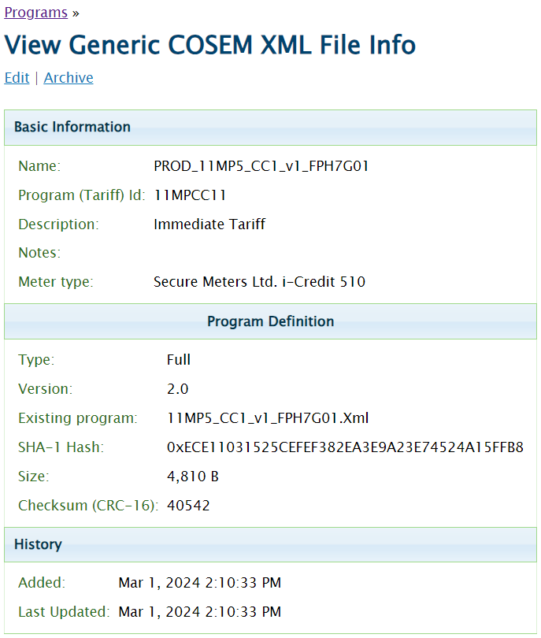

approval
Above Meter programs were reviewed and approved by Metering Engineer. The approval email is attached in the ‘Document Review’ section.

REvision History

Date | Revised By | Notes
18/03/2024 | KNjuguna | Initial Draft

